PRICE QUOTATION FORM

Name of Bidder:
Date of the quotation: | Click here to enter a date.
Request for quotation Nº: | UNFPA/IDN/RFQ/22/003
Currency of quotation: | IDR
Validity of quotation:
(The quotation must be valid for a period of at least 3 months after the RFQ submission deadline)

- Quoted rates must be exclusive of all taxes, since UNFPA is exempt from taxes.
- In case of discrepancy between unit price and total price, the lower price shall prevail and the higher price shall be corrected. If the Bidder does not accept the correction of errors, its Proposal will be rejected.

TABLE A: Video for Youtube and social media
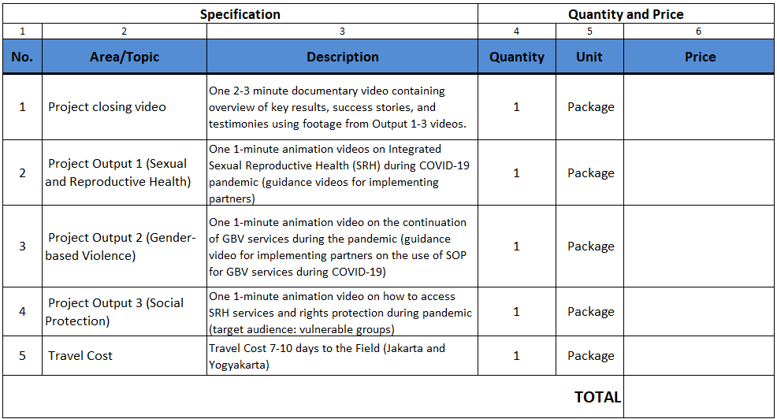

Table B: Photographs
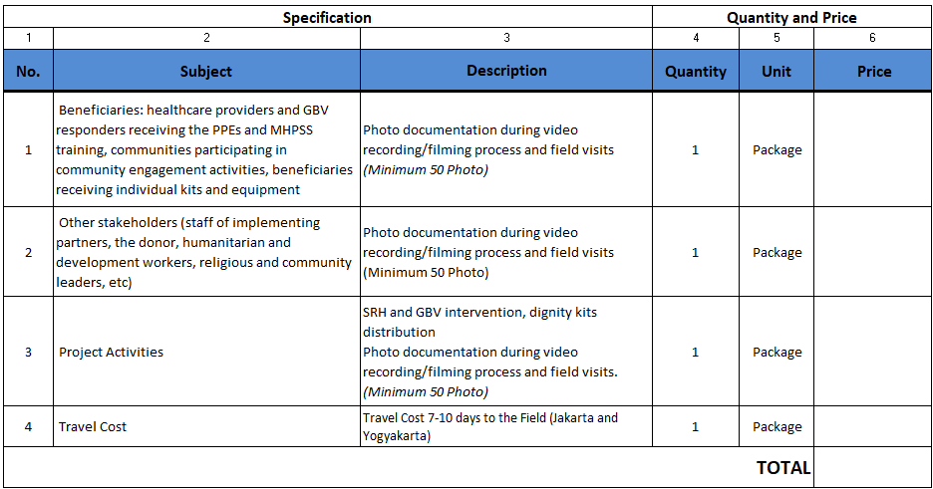

Table C: Layout & Design for Social Media Content
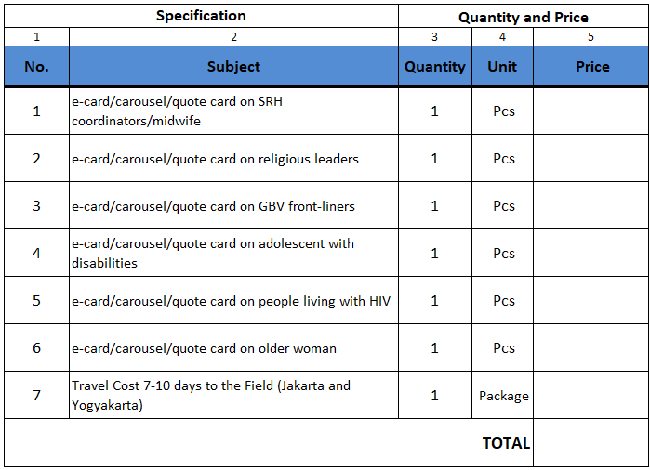

Table D: Layout & Design for Infographics
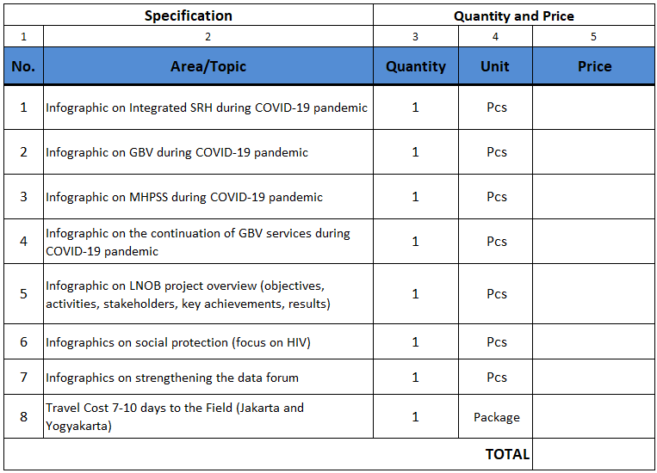

Table E Summary: Proposal for Development of Communication Materials
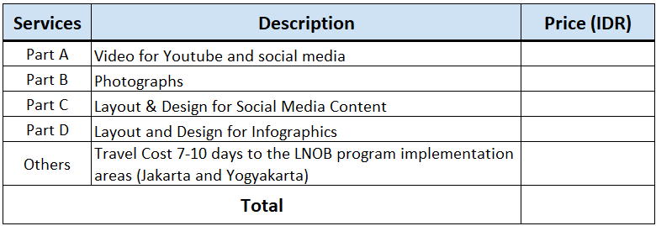

TABLE F: Offer to Comply with Other Conditions and Related Requirements
Other Information pertaining to our Quotation are as follows: | Your Responses
 | Yes, we will comply | No, we cannot comply | If you cannot comply, pls. indicate counter  proposal
After the closing date (RFQ submission deadline), if required, the bidder(s) will be contacted for clarification | [insert  answer] | [insert  answer] | [insert answer]
Delivery Lead Time as per workplan proposed, with maximum delay two calendar days and no later on 28 March | [insert  answer] | [insert  answer] | [insert answer]
Validity of Quotation is 1.5 months after the RFQ submission  Deadline | [insert  answer] | [insert  answer] | [insert answer]
All Provisions of the UNFPA General Terms and Conditions | [insert  answer] | [insert  answer] | [insert answer]

I hereby certify that the company mentioned above, which I am duly authorized to sign for, has reviewed RFQ UNFPA/IDN/RFQ/21/019 including all annexes, amendments to the RFQ document (if applicable) and the responses provided by UNFPA on clarification questions from the prospective service providers. Further, the company accepts the General Conditions of Contract for UNFPA and we will abide by this quotation until it expires.

[insert name, title, signature and company’s  seal/stamp] | [insert date and place]
Name and title | Date and place

